**INTERNSHIP REPORT**

**ON**

**PYTHON COMPETATIVE CODING**

**A internship Report is submitted**

**In accordance with requirement of degree of**

**BACHELOR OF TECHNOLOGY**

**IN**

**ELECTRICAL AND ELECTRONICS ENGINEERING**

Submitted by

K. VENKATA SAI TEJA

22KQ5A0214

Under the Mentorship of

**M.SHRAVAN KUMAR**



**DEPARTMENT OF ELECTRICAL AND ELECTRONICS ENGINEERING**

PACE INSTITUTE OF TECHNOLOGY AND SCIENCES (AUTONOMOUS)

(AffiliatedtoJawaharlalNehruTechnologicalUniversityKakinada,Kakinada&

Accredited by NAAC ‘A’ GRADE,An ISO 9001-2015 Certified Institution)

NH-16, Valluru Post , Prakasam District, A.P-523272.

(2024-2025)

**PROJECT TITLE**

**HOTEL MASTER NEXUS**

**DATE: JUNE 11TH 2024**

**NAME: K. VENKATA SAI TEJA**

**PROJECT DETAILS:**

**ABSTRACT:** The objective of this project is to create a comprehensive hotel management system that can handle various aspects of hotel operations, including reservation management, guest check-in/check-out, room assignment, billing, and reporting.

**DESCRIPITION**:This project about effective allotment of hotel rooms to the customer by some factors like allotments, number of days, price based, requirement based, analysis. The aim to make fullfill the customer criteria and satisfaction giving Hotel free stay.

**REQUIREMENTS** :

1. How many rooms available.

2. How many rooms allotted .

3. Updating rooms are available every 2 hours .

4. How much cost for shift.

5. How many employees are working.

6. Daily how many rooms are report

7. Please salary credit is the employees account.

8.monthly income report.

**APPROACH:**

* **Home()-** Function to display the project’s main screen i.e. the home page of the project or you can say the main menu for selecting the desired operation to perform.
* **Booking()-** Function for booking room in hotel by entering user/customer details.
* **Room_Info()-** Function to provide users/customers with hotel rooms information(i.e. about room amenities).
* **Record()-** Function for keeping records of customers stayed in the hotel.

**PROGRAM SOURCE CODE:**

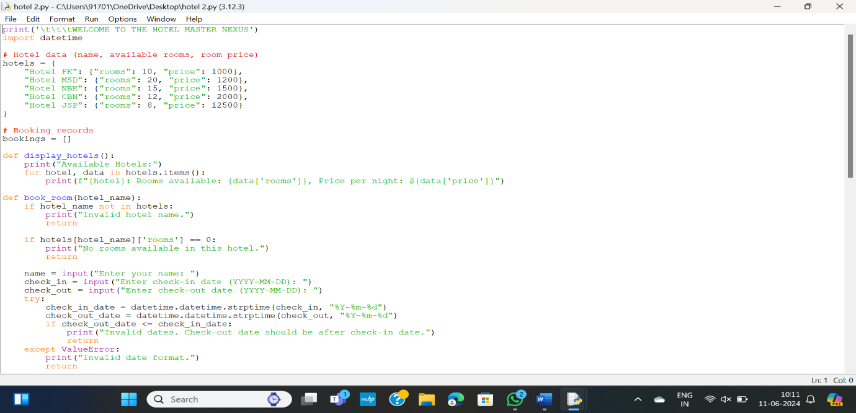

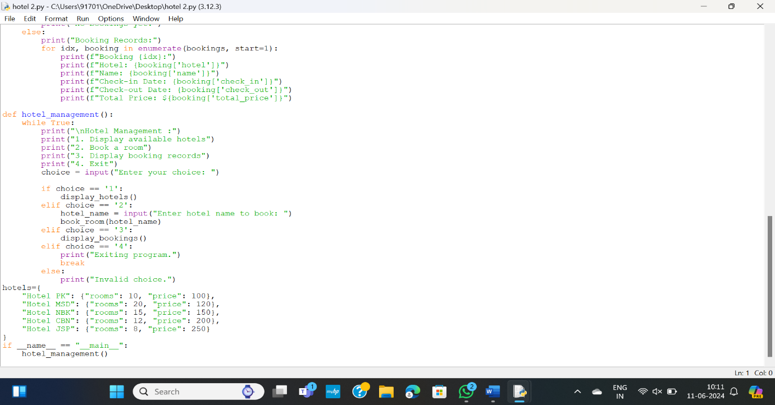

**OUTPUT:**

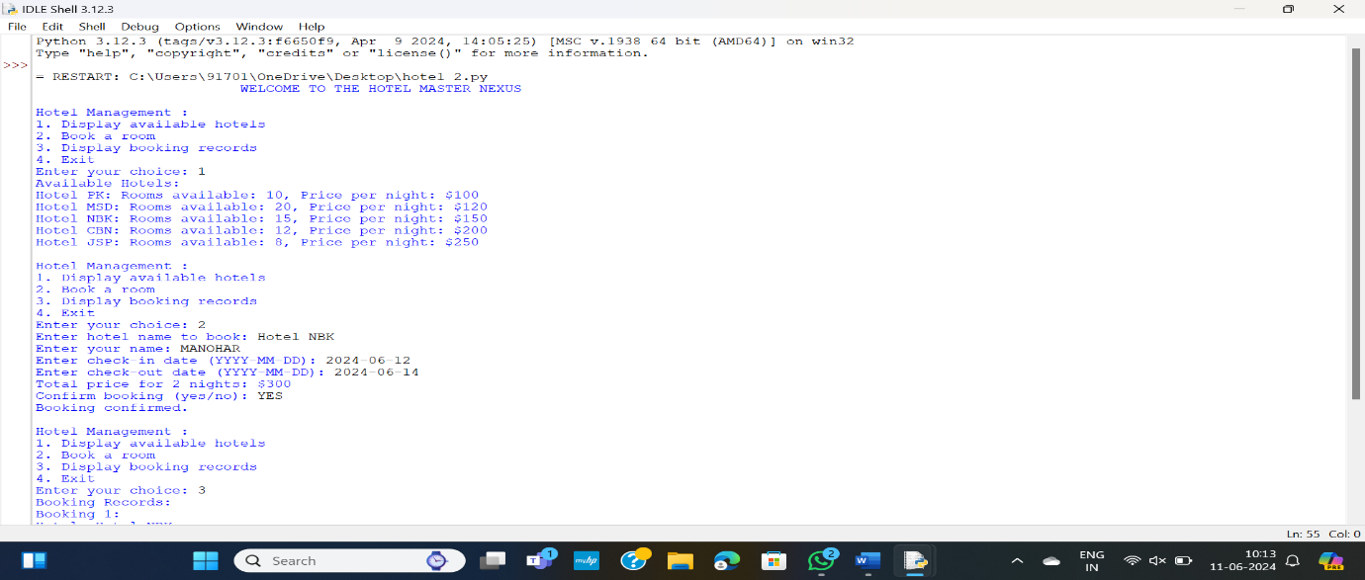

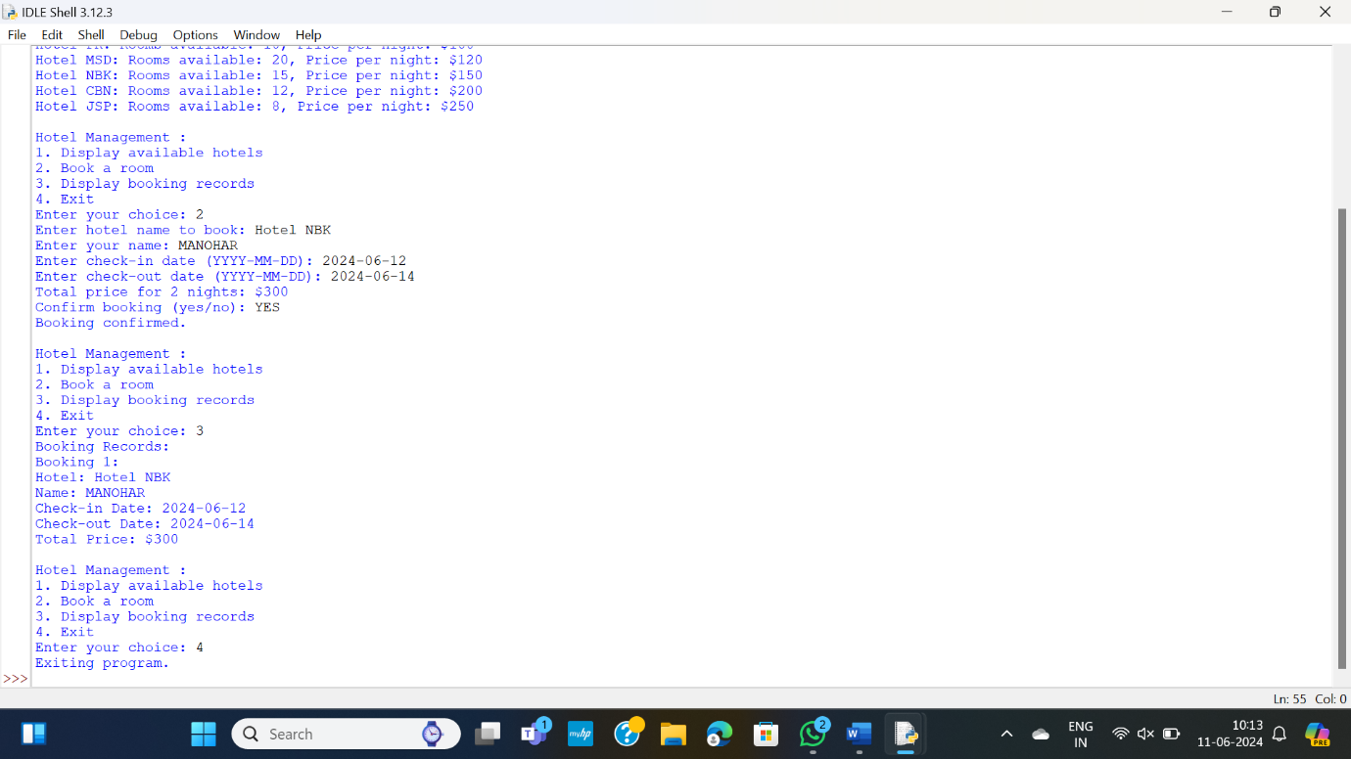

**EXPLANATION:**

This Project on Hotel Management is a general software developed (using Python) to simplify hotel operations by automating them. In this project, “Hotel Master Nexus” is the project’s hotel name. It covers major aspects of hotel management; it could perform the following operations- Hotel Booking, Provide you with Hotel ,Rooms Info and Record-Keeping.

**1**.**Printing Welcome Message**:This line simply prints a welcome message to the user when the program starts.

**2.Hotel Data**: Here, a dictionary named hotel is defined. Each key-value pair in the dictionary represents a hotel. The key is the hotel name, and the value is another dictionary containing the number of available rooms ("rooms") and the price per night ("price").

**3. Booking Records:**An empty list named bookings is initialized. This list will store the booking records.

**CONCLUSION**:

Your code structure is clear and easy to follow. It would be great to see further enhancements like error handling, validation checks, and maybe adding more functionalities such as canceling bookings or modifying existing bookings. Keep up the good work! Let me know if you need further assistance